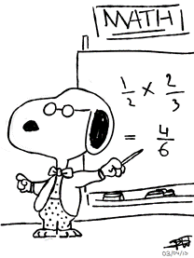

**Reminders**

**Drama/Music** - Wednesdays  
**Italian** – Tuesday

**Gymnastics** - Monday

**Library** - Wednesday

**Borrowing** -Thursday  
**Sport**-Monday and Friday

**Assembly**- Fridays 2.30pm

**Readers changed everyday**

**Students are encouraged to read a book every night for a minimum of ten minutes as well as enjoying a book read to them by their parents.**

**Sight Words to be revised every night**

**Mathematics**

**Early Days:**

Children will learn about routines and processes that allow them to become familiar with school life.

**Patterns in my Environment:**

* explore patterns by copying and modelling patterns;
* revise numbers 1-5 and explicitly teach numbers 6-7; and
* continue to count forwards and backwards identifying numbers before and after, more than and less than.

**Shapes in the Environment:**

* explore shapes in the environment;
* manipulate, sort and classify 2D and 3D shapes; and
* revise numbers 1-7 and explicitly teach numbers 8-10.

**The Arts**

**Visual Arts:**

This term wewilldevelop skills and techniques in making, presenting and reflecting on art, craft and design works using a variety of materials. Visual Arts projects are closely related to all subject areas.

**Music:** Students in Kindergarten will explore pitch, beat and rhythm through movement and song.

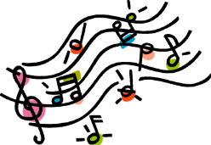



**Term Events**

**Masses/Liturgies**

26th March -Ash Wednesday Mass 12.30pm

**Important Dates**

24h Feb -Information about Reading K-2

27th Feb- Swimming Carnival K-6

28th Feb- Interim Reports sent home

2nd Mar- Three Way Conferences

3rd Mar- Three Way Conferences

8th Mar- School Mass 10am

15th Mar Family Mass 9am

2nd April- Learning Show Case 2pm

3rd April School Mass 10am

3rd April Ways of Being Award Ceremony 2.30pm

7th April- Holy Week Liturgies

8th April- Holy Week liturgies

9th April- Holy Thursday/ Term 1 concludes

**PDHPE**

**Growth and Development:**

Students will learn about and develop skills to encourage and care for others. This unit builds on knowledge and understandings of student practices for making and maintaining friends.

**Sport and Gym**

Students will engage in weekly gymnastics (Mondays), athletics clinic from week 5 and Gross Motor activities. Students will learn the importance of safety in sport, as well as developing fundamental movement skills.

**Italian**

Students will learn greetings, how to introduce themselves, count from 1 to 10, discover what happens at Carnevale and how to enjoy an Italian Easter.