4506



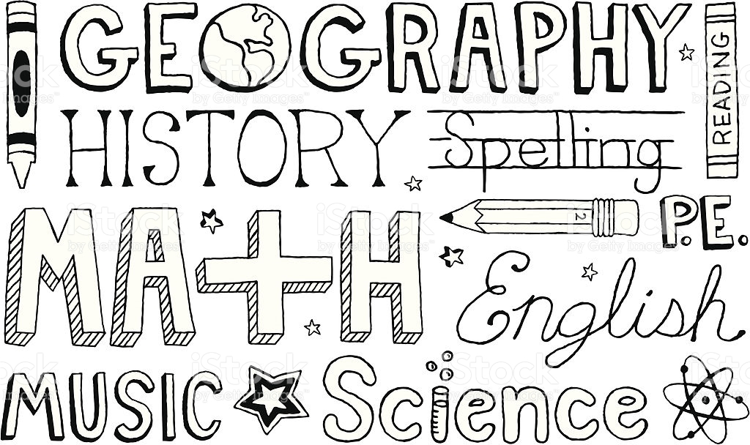

**‘Be the Living Gospel’**

**Kindergarten**

**Term 1 Overview 2020**

**Developing Our Learning Culture**

By practising good habits for our mind and social skills for how to work effectively with others, we are developing life-long skills.

Kindergarten will investigate:

* learning preferences in our classroom;
* social skills and habits for life;
* rules for our classroom; and
* the Five Ways of Being.

**Shaping Identity**

This conceptual unit has been linked with Health, Science, Social Sciences and Religion.

The conceptual understanding that Kindergarten students will explore is: *Relationships are enhanced by a sense of self.*

The concepts that the students will explore are:

* Identity;
* Relationship; and
* Belonging

Through the above concepts the students should come to understand:

* Self and identity;
* How to form positive relationships; and
* What it means to belong to a community.

**Religion**

Students will learn about some Old Testament and New Testament stories that tell of a God of love, the creator of all, the goodness of God's creation, God's special relationship with all of creation and God's plan that people help each other to live safely and happily together, for the good of all.

**Skills:**

Share feelings and thoughts about some of Jesus' key messages about love, compassion and forgiveness; and

* Identify connections between Jesus' key messages about love, compassion and forgiveness and their personal experience.

**Religious Knowledge and Deep Understanding**

According to Christian teaching, God created people as rational beings with the freedom to choose. Choices between good and bad, right and wrong involve the whole person - emotions, feelings and reasoning.

**Skills:**

* Identify examples from scriptural texts, including the Ten Lepers (Luke 17:11-18), where people have the freedom to choose between good and bad, right and wrong; and
* Explore the emotions, feelings and reasoning involved when people make choices between good and bad, right and wrong and make connections with their personal experiences.

**Digital Technology**

Students will begin to use digital systems to represent simple patterns in data in different ways.

They will begin to design solutions to simple problems using a sequence of steps and decisions.

Students will collect data and display them to convey meaning.

**English**

Students will learn torecognise and write upper and lower case letters.

They will begin to understand how we make meaning through language using rhymes, syllables, letter-sound relationships, punctuation, words and sentences.

Students will begin to understandthat books are created by authors. They will be exposed to a variety of big books, pictures and factual books, which will develop the interest level of the children in reading and choosing their own reading material.

We will begin to develop skills to create an environment that nurtures a community of enthusiastic and engaged readers and writers.